|  |
| --- |
| ***Date: 24 /4 /17***  **[ cloud computing ]** |
|  |

Practical: 8

**Aim: - Aneka a cloud Application development platform**

Submitted By: Mahek shah,Homi varma,purva patel

Enrollment No:15012011044,15012011050,15012011058



**GANPAT UNIVERSITY**

**U. V. Patel College of Engineering**

**Computer Engineering Department**

**What is Aneka?**

* Platform for deploying Clouds developing applications.
* Service Oriented Architecture (SOA).
* Provides a runtime environment and set of APIs.
* Choice for flexible, extensible .NET enterprise Cloud application and deployment.
* As a platform it provides users with both a runtime environment for executing applications and a set of APIs and tools that allow you to build new applications or run existing legacy code.
* It was initially developed within the Gridbus project and then commercialized by Manjrasoft.
* An Aneka Cloud is composed of a collection of services deployed on top of an infrastructure.
* This infrastructure can include both physical and virtual machines located in your local area network or Data Centre.
* Aneka services are hosted on Aneka Containers which are managed by Aneka Daemons.
* An Aneka Daemon is a background service that runs on a machine and helps you to install, start, stop, update and reconfigure Containers.
* A key component of the Aneka platform is the Aneka Management Studio, a portal for managing your infrastructure and clouds.
* Administrators use the Aneka Management Studio to define their infrastructure, deploy Aneka Daemons, and install and configure Aneka Containers.
* The Aneka based computing cloud is a collection of physical and virtualized resources connected through a network, which are either the Internet or a private intranet.
* Each of these resources hosts an instance of the Aneka Container representing the runtime environment where the distributed applications are executed.
* ANEKA allows servers and desktop PCs to be linked together to form a very powerful computing infrastructure. This allows companies to become energy efficient and save money without investing in greater numbers of computers to run their complex applications.

**What is an Aneka Cloud composed of?**

* An Aneka Cloud is composed of a collection of services deployed on top of an infrastructure.
* **Aneka Cloud**, composed of a **Master Container** that is responsible for scheduling jobs to **Workers**, and a group of **Worker Containers** that execute the jobs. Each machine is typically configured with a single instance of the Aneka Daemon and a single instance of the Aneka Container.
* **Aneka services** are hosted on Aneka Containers which are managed by Aneka Daemons.
* An **Aneka Daemon** is a background service that runs on a machine and helps you to install, start, stop, update and reconfigure Containers.

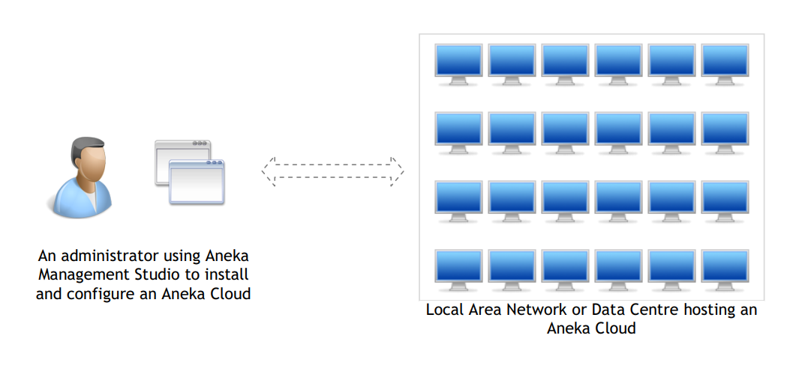

**What is an Aneka Cloud composed of?**

* An Aneka Cloud is composed of a collection of services deployed on top of an infrastructure.
* **Aneka Cloud**, composed of a **Master Container** that is responsible for scheduling jobs to **Workers**, and a group of **Worker Containers** that execute the jobs. Each machine is typically configured with a single instance of the Aneka Daemon and a single instance of the Aneka Container.
* **Aneka services** are hosted on Aneka Containers which are managed by Aneka Daemons.
* An **Aneka Daemon** is a background service that runs on a machine and helps you to install, start, stop, update and reconfigure Containers.

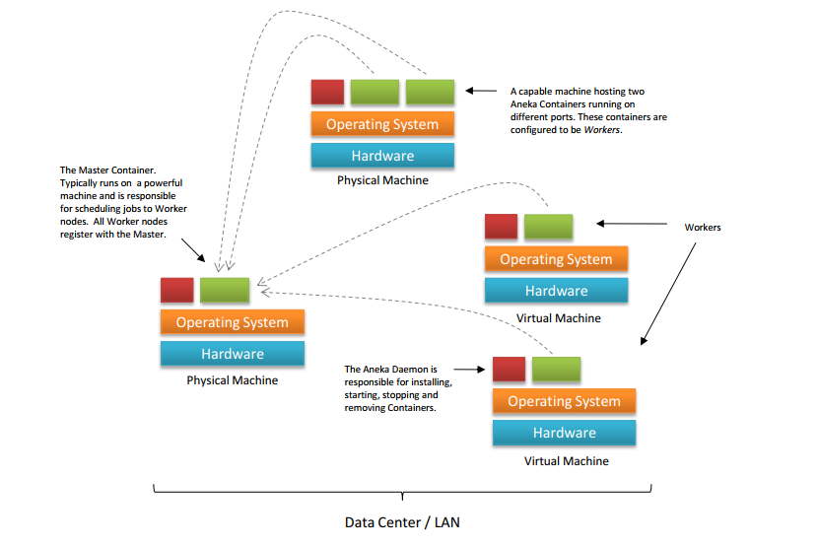

**Aneka Framework:**

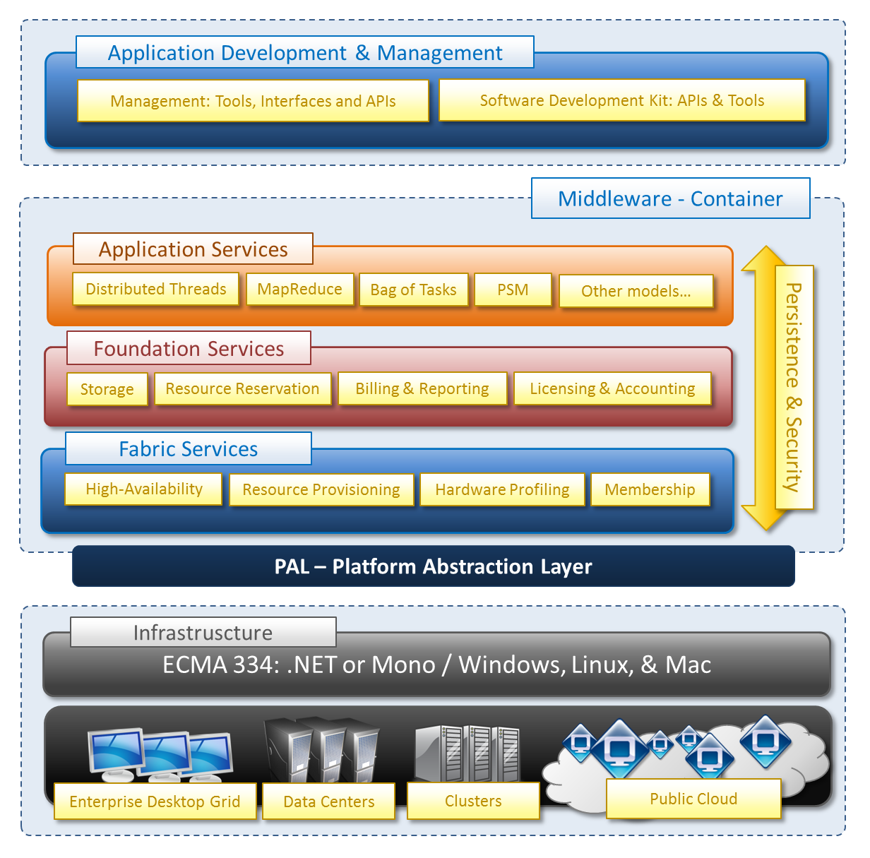

**ADVANTAGES:**

* **Reduced Costs**
* **Improved Reliability** :Aneka’s ability to design and create a solid fault tolerant system infrastructure without having to build topology level knowledge base into applications simplifies the application development and automatically manages application load over Clouds, Grids, clusters, or desktops. This gives a newfound level of resiliency with a guaranteed quality of service and effective metering and monitoring for all the service.
* **Simplicity**: Aneka offers the most flexible and robust APIs framework that cleanly handles .NET based enterprise application management and development with lightweight technology and flexible application integration approaches. Aneka aims to be more general and empower any kind of application that suffers from performance degradation and lack of responsiveness under huge pressure.
* **Seamless Scalability**: Aneka helps enterprise customers to enrich their applications and services with support for distributed and scalable runtime environments for multicore desktops, servers and a network of computing systems that are presented as Clusters, Grid, and Clouds. Aneka empowers the enterprise application stack to achieve end-to-end performance, scalability and high availability thus meeting the service levels agreement and providing the desired quality of service.
* **Faster Time to Value**: By unraveling both the immediate technical and business challenges of Cloud integration, Aneka allow enterprise business to effectively adopt Cloud based application through faster time to market scenario with minimal budget.
* Aneka provides a more **flexible model** for developing distributed applications and provides integration with external Clouds such as Amazon EC2 and GoGrid.(Microsoft Azure leverages the infrastructure provided by Microsoft only)
* Aneka is a middleware that can be deployed in the private infrastructure thus maximizing the use of the local existing infrastructure and allowing enterprises to **comfortably scale to the Cloud** when needed.

**PRIVATE CLOUD SETUP USING ANEKA**

* **INSTALLATION**

**Step: 1** Search **download aneka** in google. And click on very first suggestion.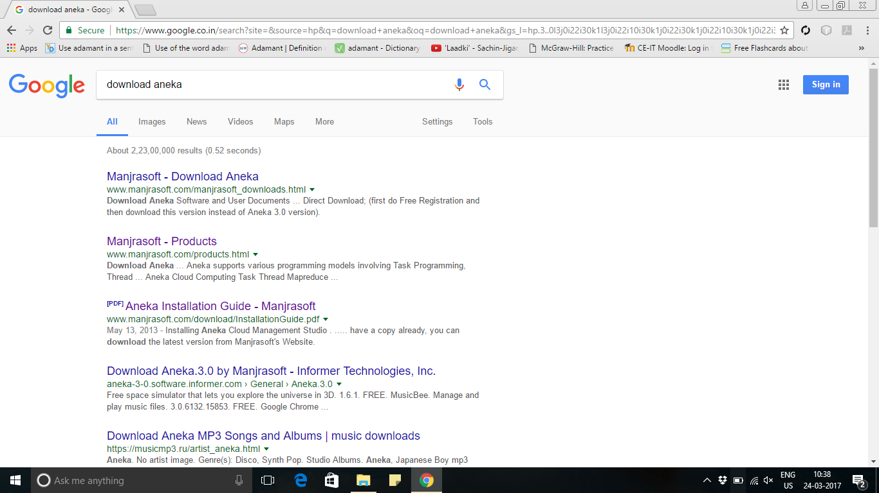

**Step: 2** Click on **Free registration and download**.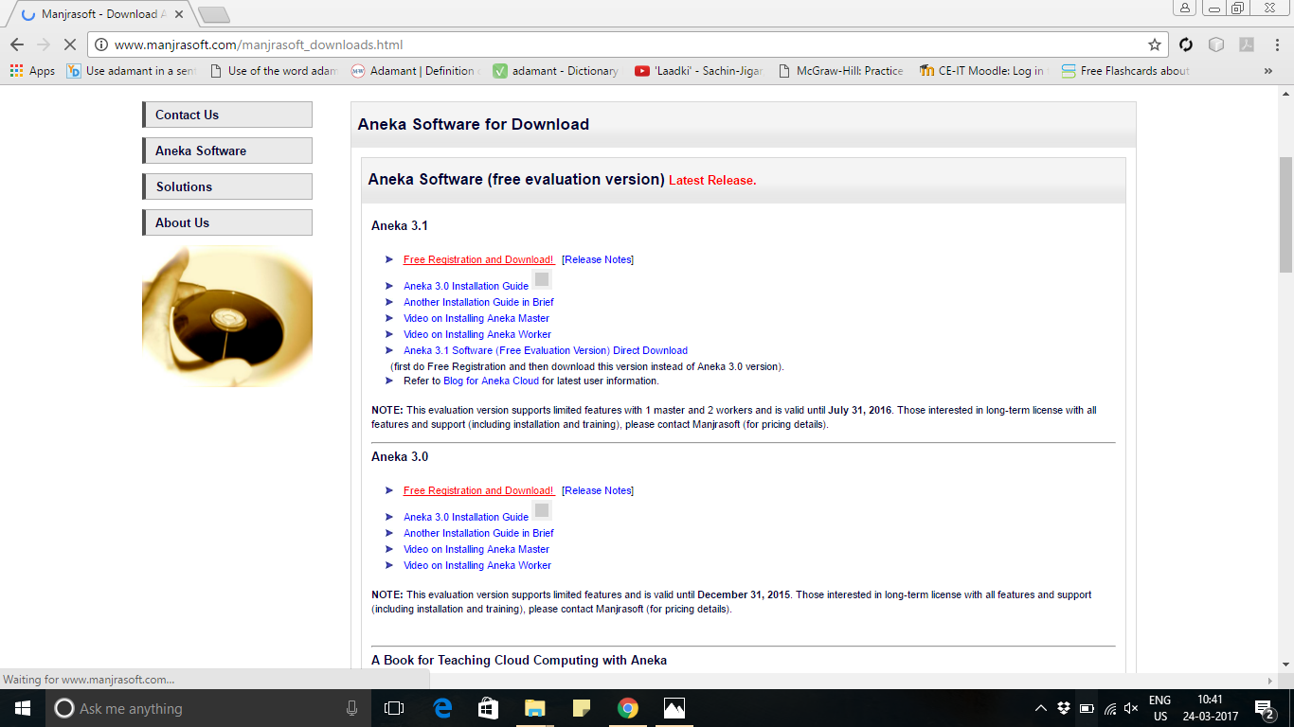

**Step: 3** provide your **Name, Affiliation, Email, Phone** and **Click Register.**

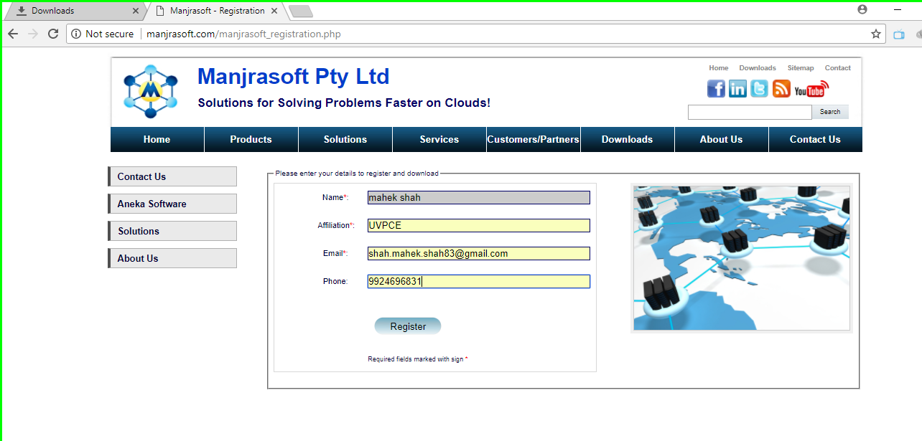

**Step: 4** open your registered email-id, open the mail from aneka and press download link**.**

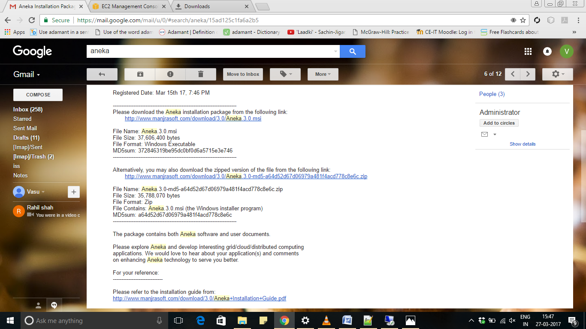

**Step: 5 Run** the downloaded .exe file and click on **next**.

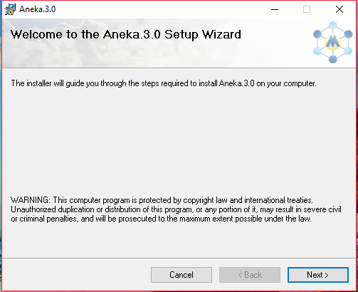

**Step: 6** Select **installation path** and also select the option of everyone or just me to access aneka in particular pc. Click **next**.

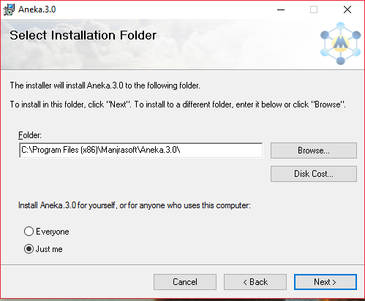

**Step: 7** Now, the installer is ready so, it will show you a message that “The installer is ready to install Aneka 3.0 on your computer”. Click **next.**

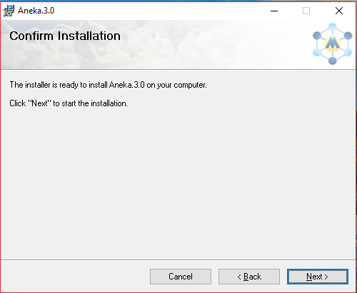

**Step: 8 Wait** till it completes installation**.**

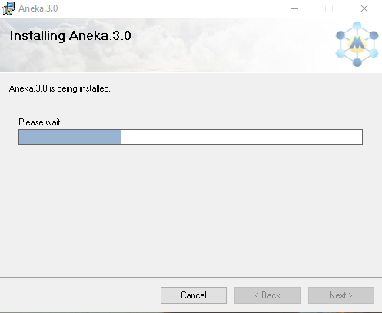

**Step: 9** Click **ok.**

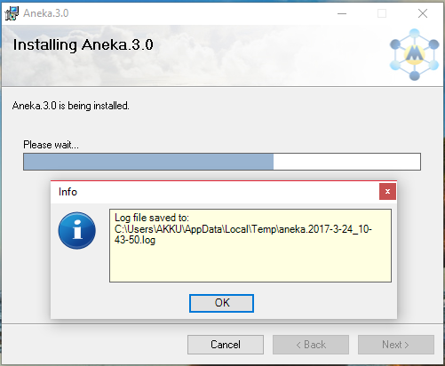

**Step: 10** Installation is successfully completed so, click on **Close.**

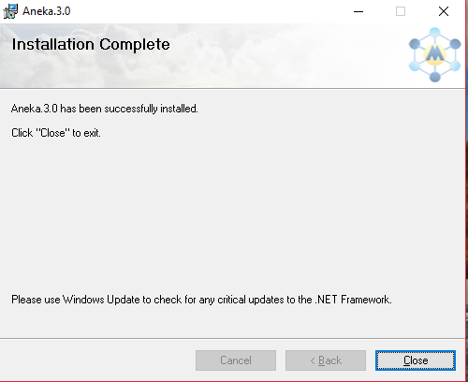

**Step: 11** Do the same process in each pc, in which you want to use Aneka**. (** In our case we installed aneka in two pc. First is the master pc in which, we will install master node and Second is the worker pc in which, we will install worker node. **)**

**Step: 12** Find out ip address of master pc**.**

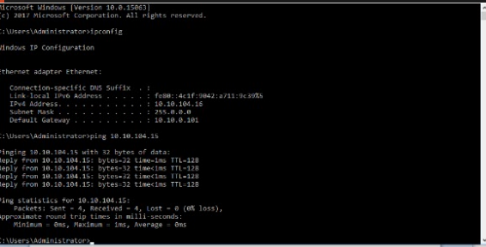

**Step: 13** Find out ip address of worker pc**.**

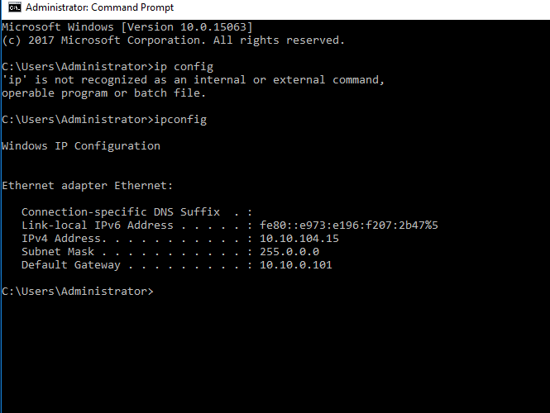

**Step: 14** Ping from master pc to worker pc**.**

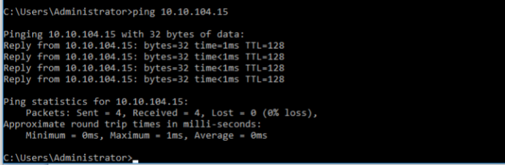

**Step: 15** Ping from worker pc to master pc**.**

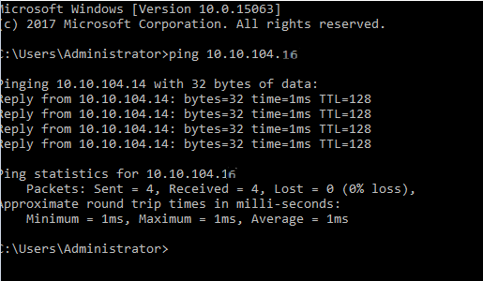

**=**

Now, we will make Master in aneka. So the steps from 16 to 28 are of master pc.

**Step: 16** Open aneka management srudio**.**

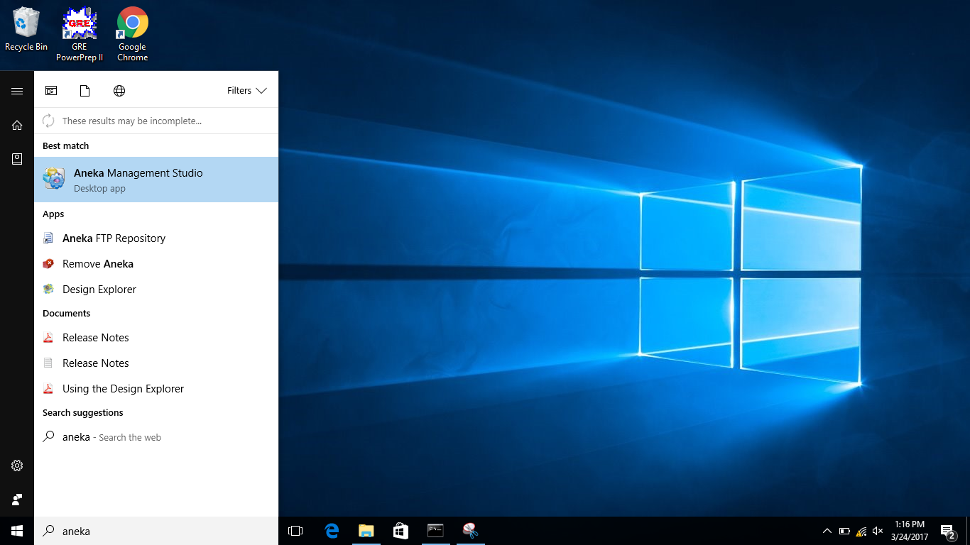

**Step: 17** File > Add machine**.**

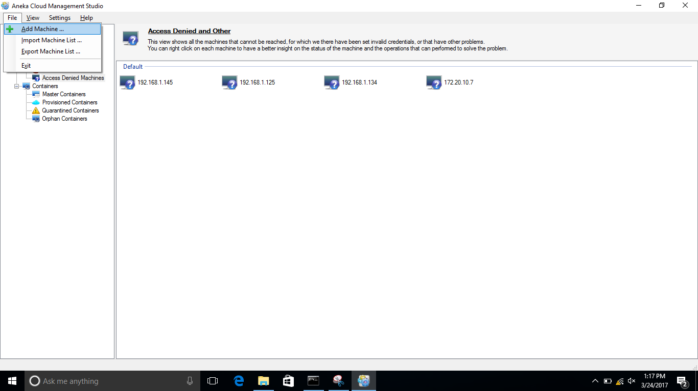

**Step: 18** Write ip address of master. Select platform windows, select credential**.** Don’t change Service port and group.

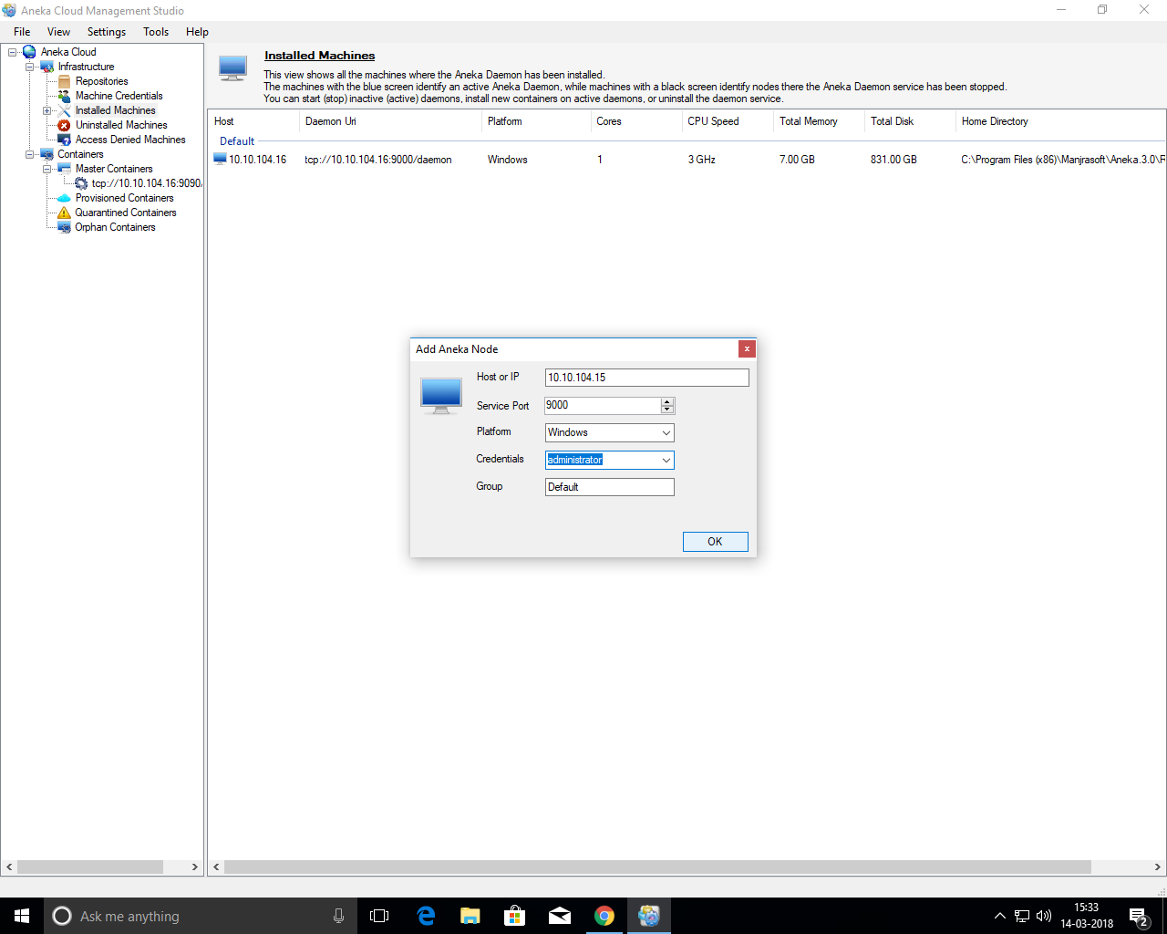

**Step: 19** you can check installed machines.

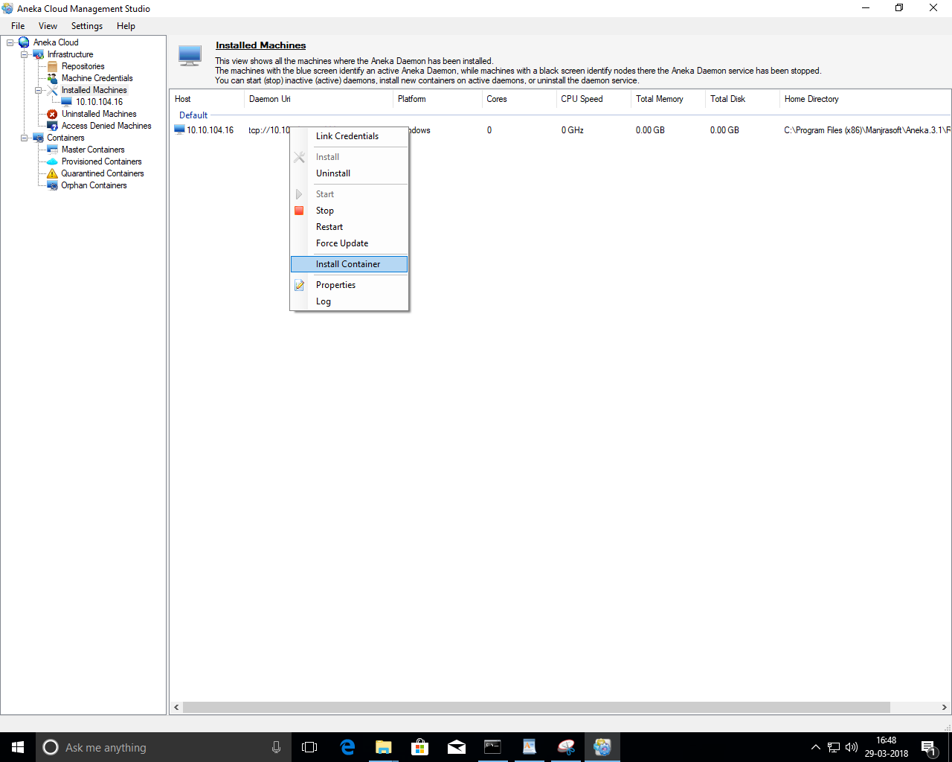

**Step: 20** Right click on installed machine and select install container.



**Step: 21** in container end point, select any random port and Probe it. When you probe, it will show the status of port that it is available or not.

In container type, there are two options. In our case we will select master.

**Note:** Remember final port number. Because, we will use it when we make worker.

click **next**.

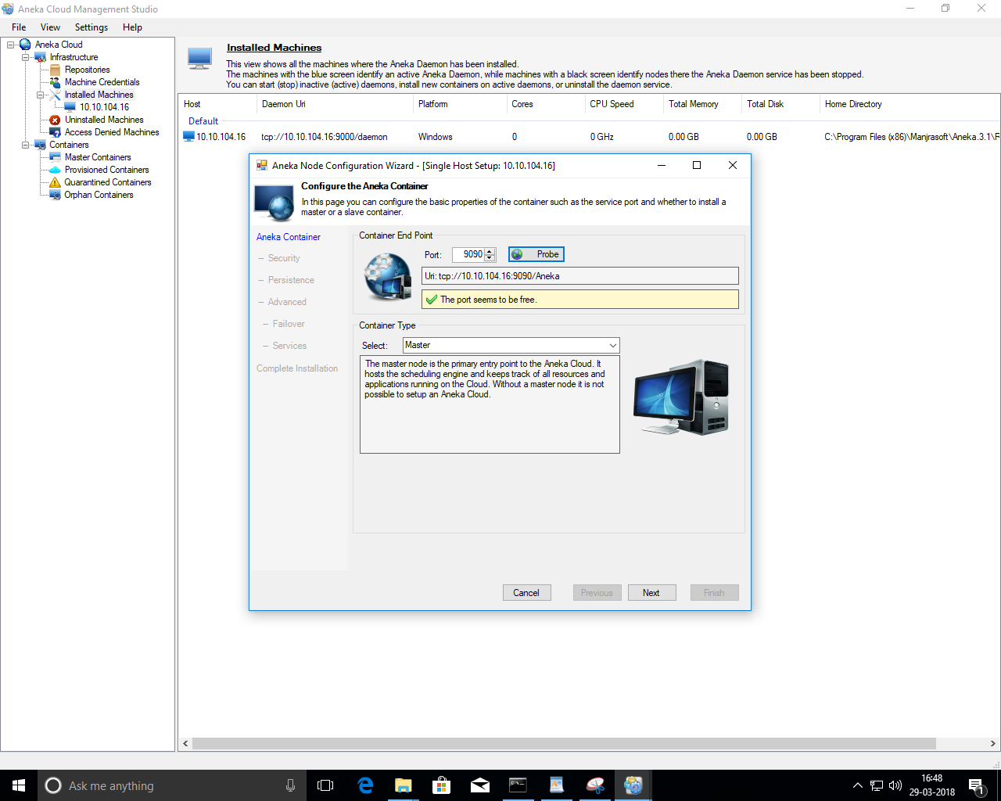

**Step: 22** click **next**.

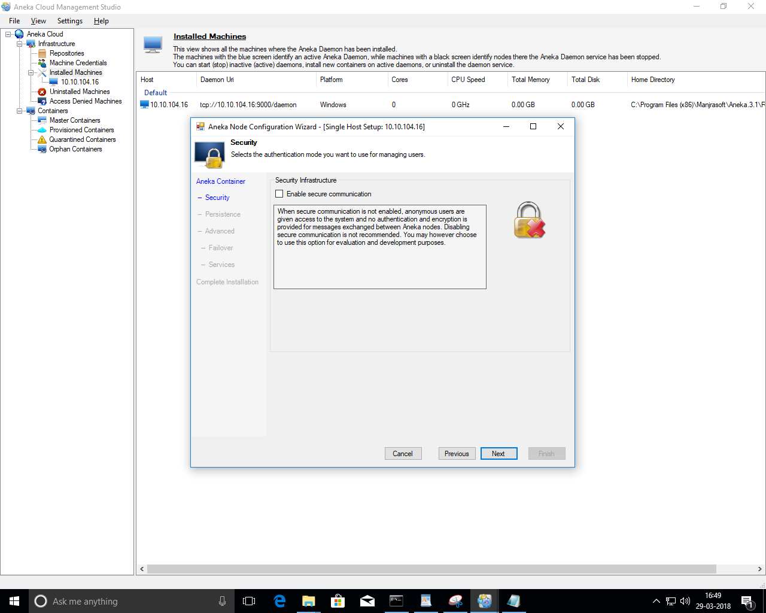

**Step: 23** Select inMemory in persistance.

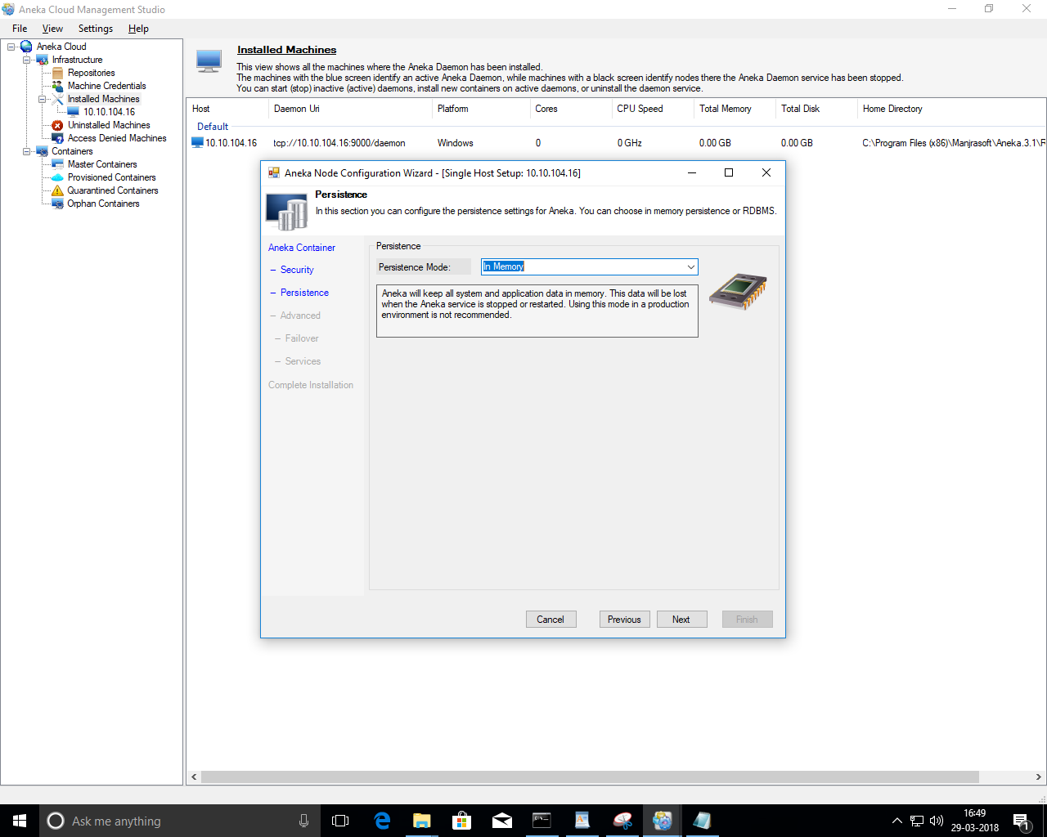

**Step: 24**

Here,you can add cost(Unit/Hour) if you want. Otherwise you can leave is as zero.

click **next**.

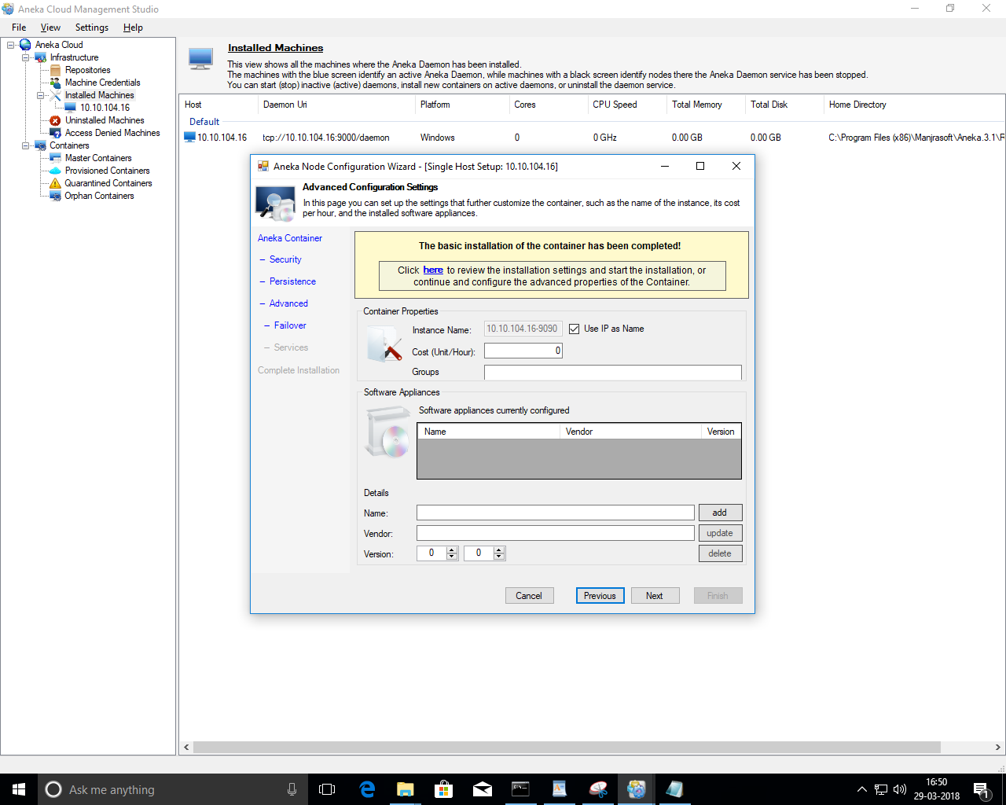

**Step: 25**

Here,In case primary master fails you can create backup master and give ip-address and port in back-up master field.

click **next**.

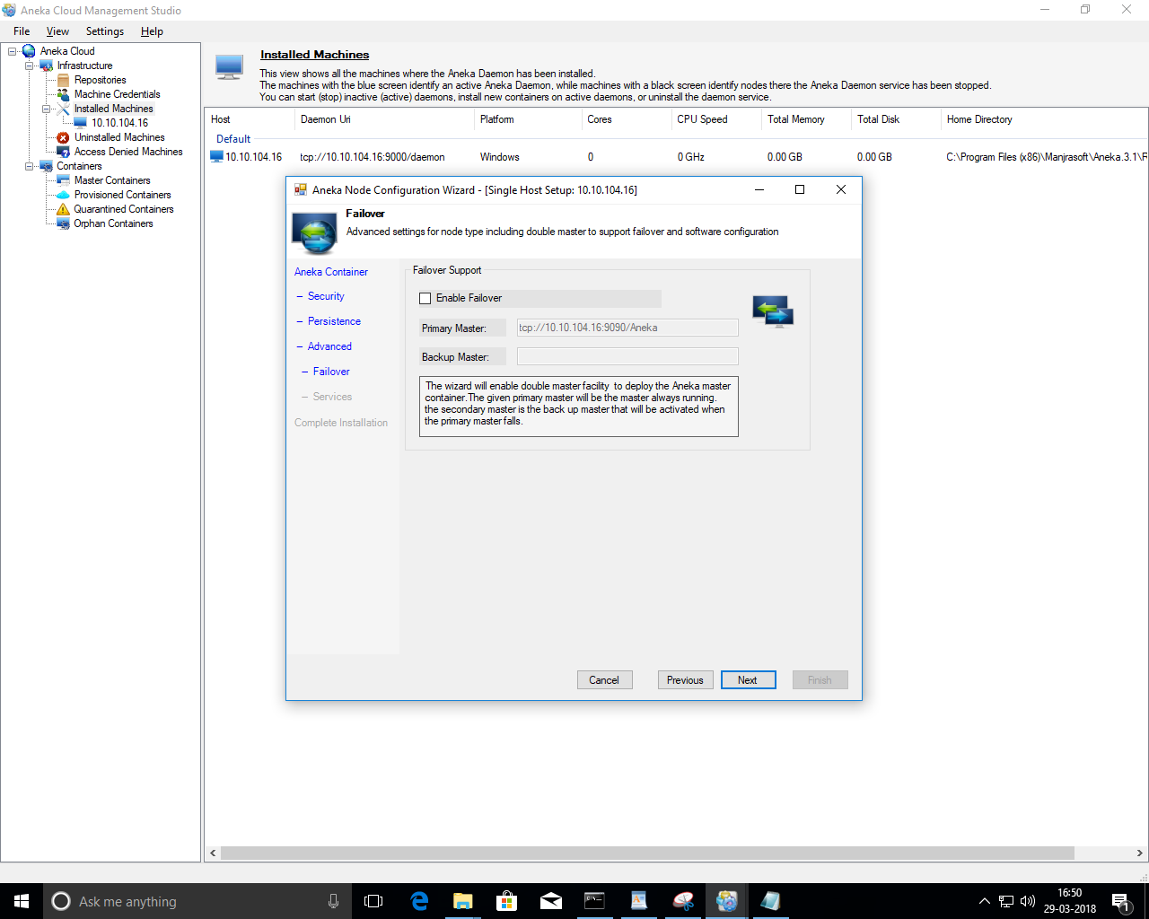

**Step: 26** check all the services and select MapReduceExecutor and enter user name and password and click **next**.

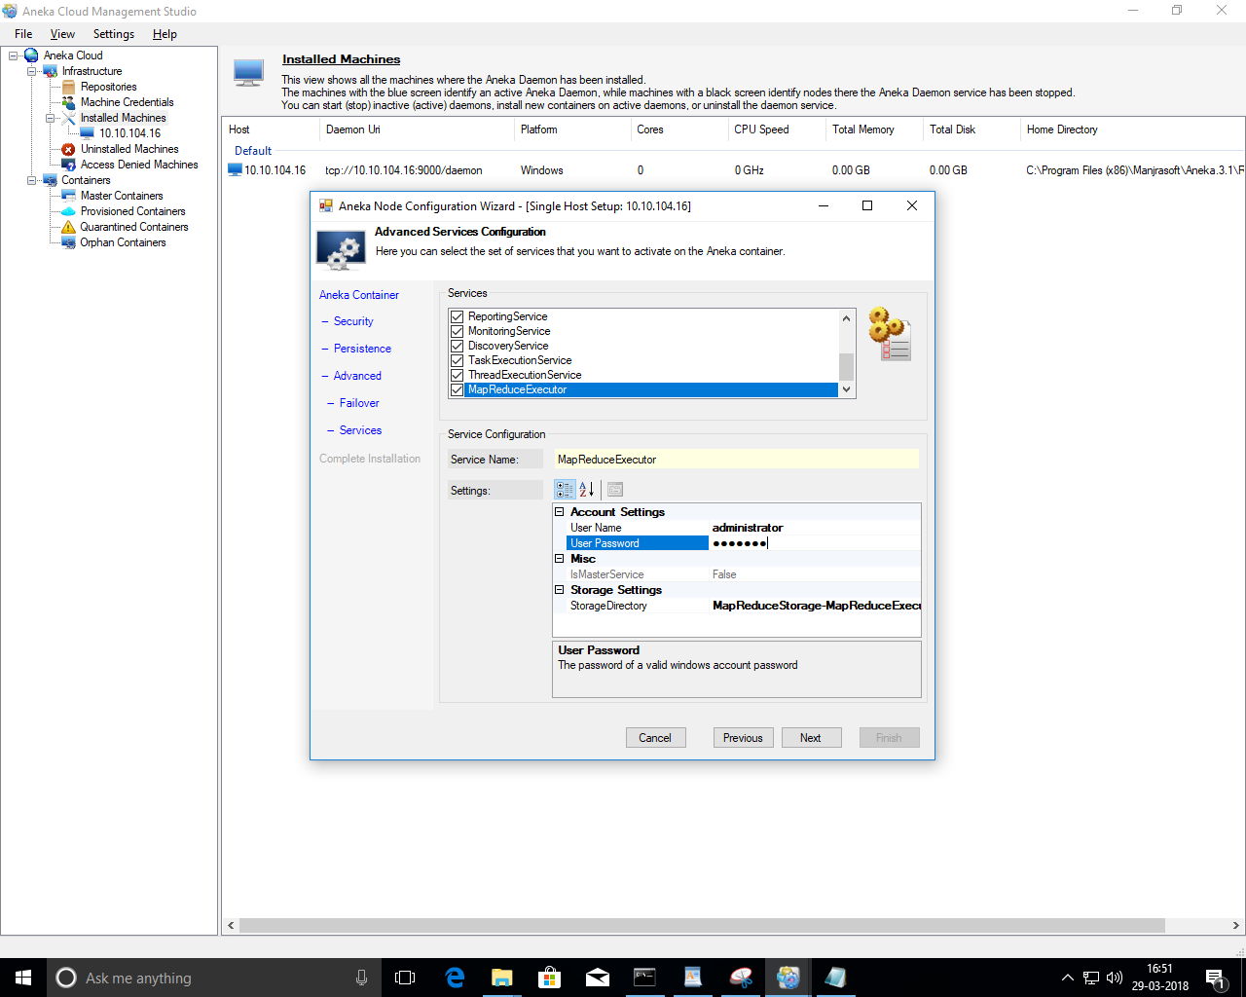

**Step: 27** click **Finish**.

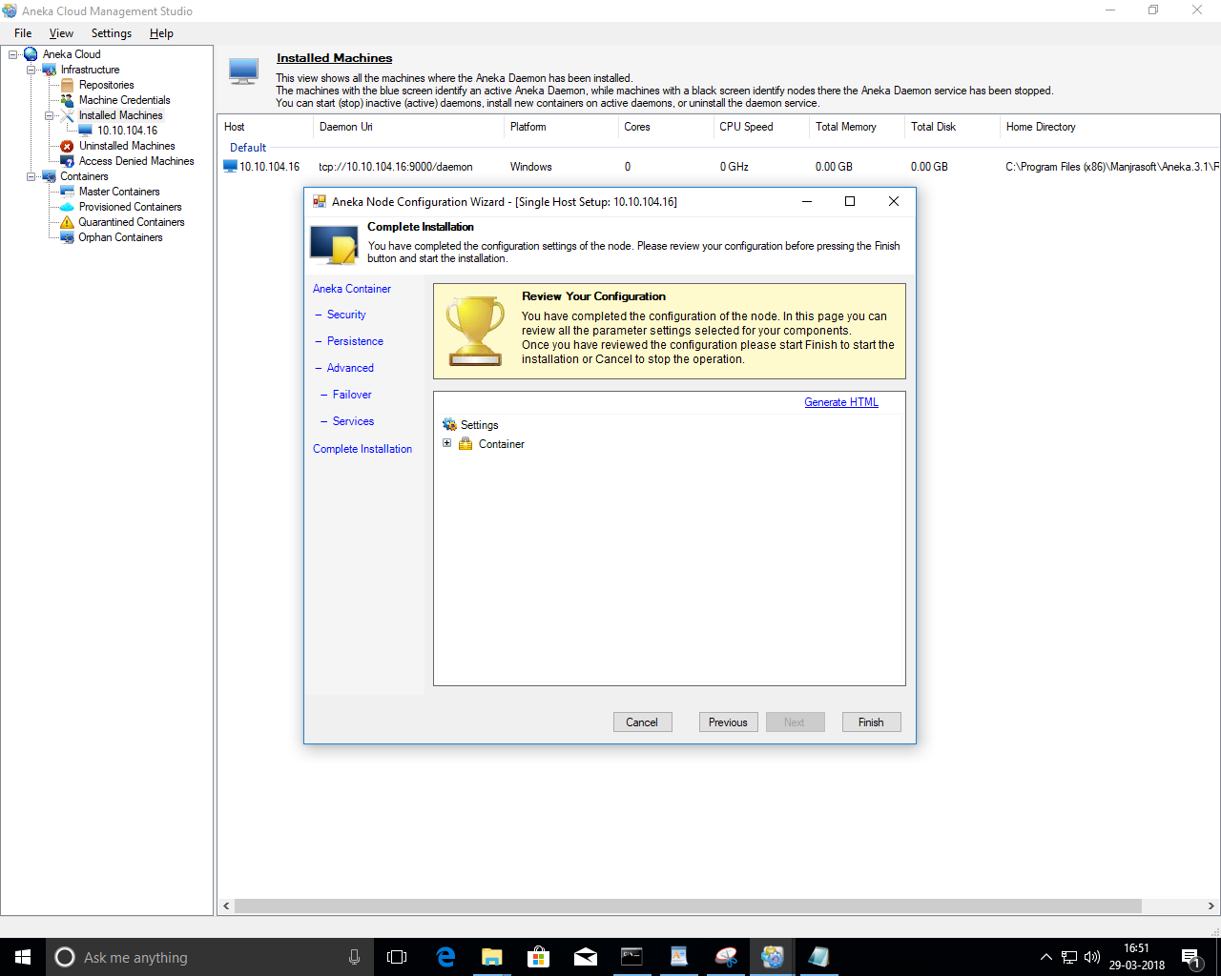

**Step: 28** It will take time so, wait till it completes the installation of master container.

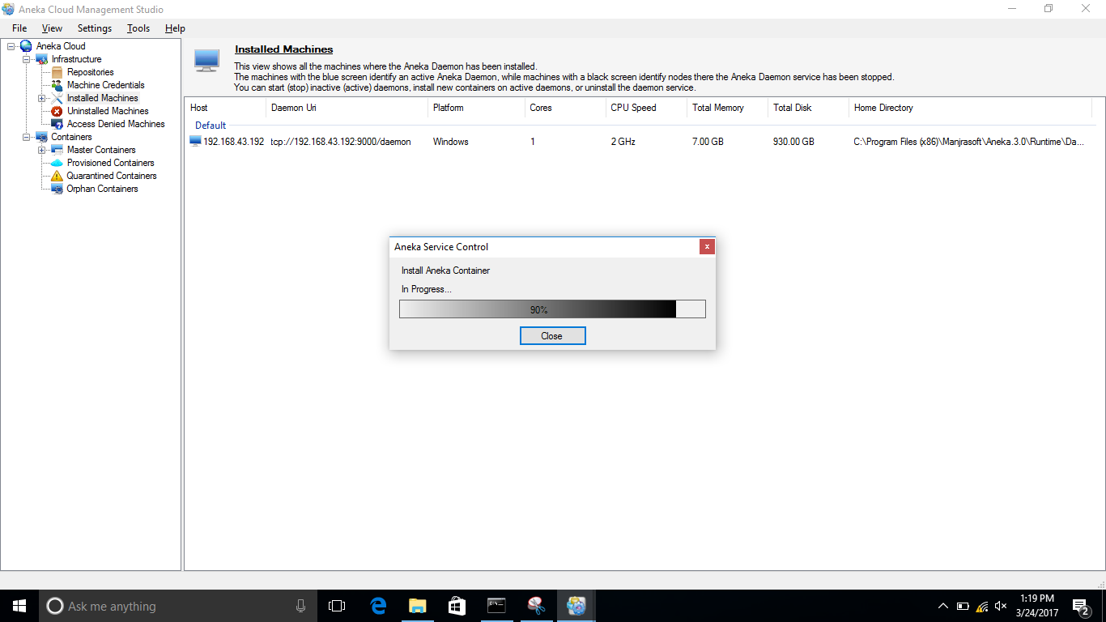

Now, we will make Worker in aneka. So the steps from 29 to 44 are of worker pc.

**Step: 29** File > Add machine.

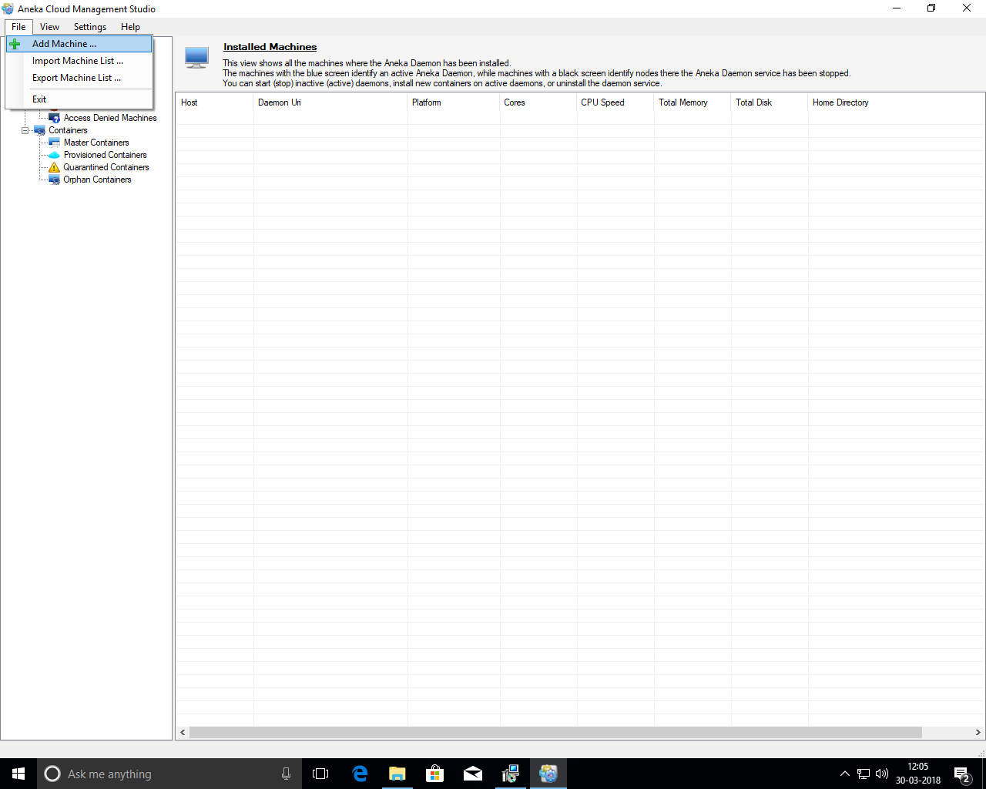

**Step: 30** Write ip address of worker. Select platform windows, select credential**.** Don’t change Service port and group.

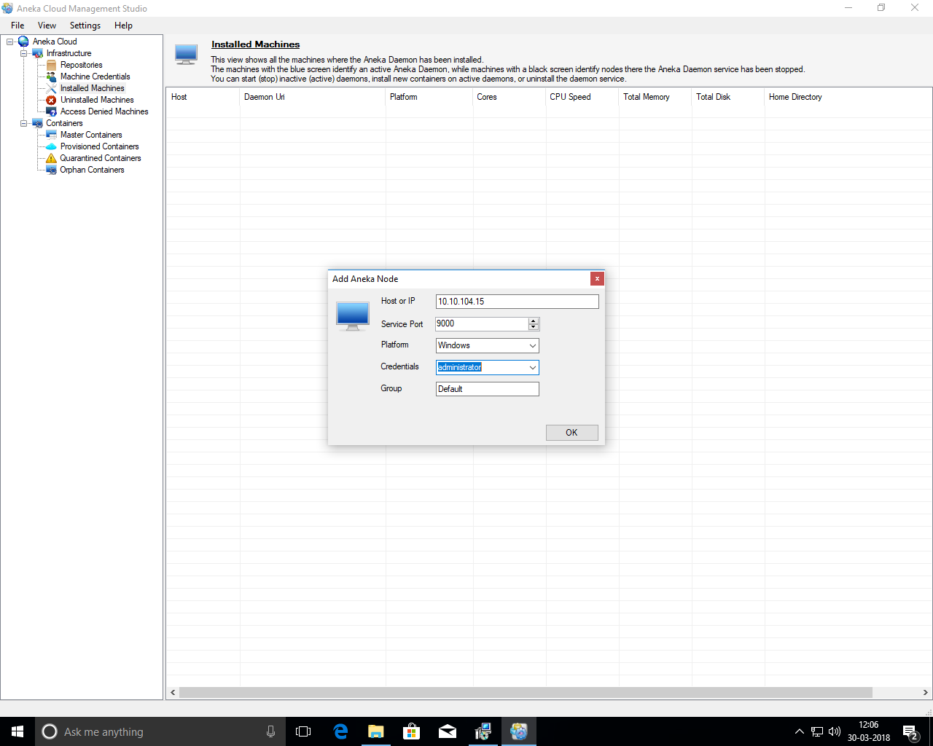

**Step: 31** You can find your machine in uninstalled machines. So, right click on it and select Install.

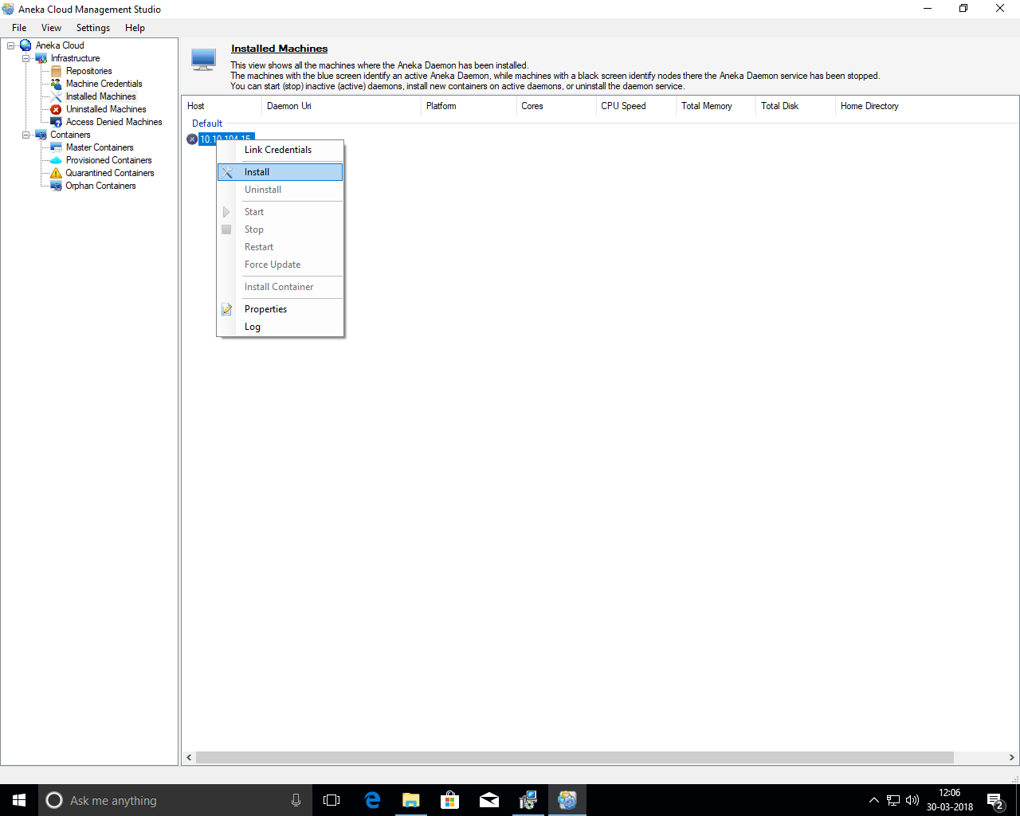

**Step: 32** select port randomly and probe it. Which will show the status of the probe. Click **next.**

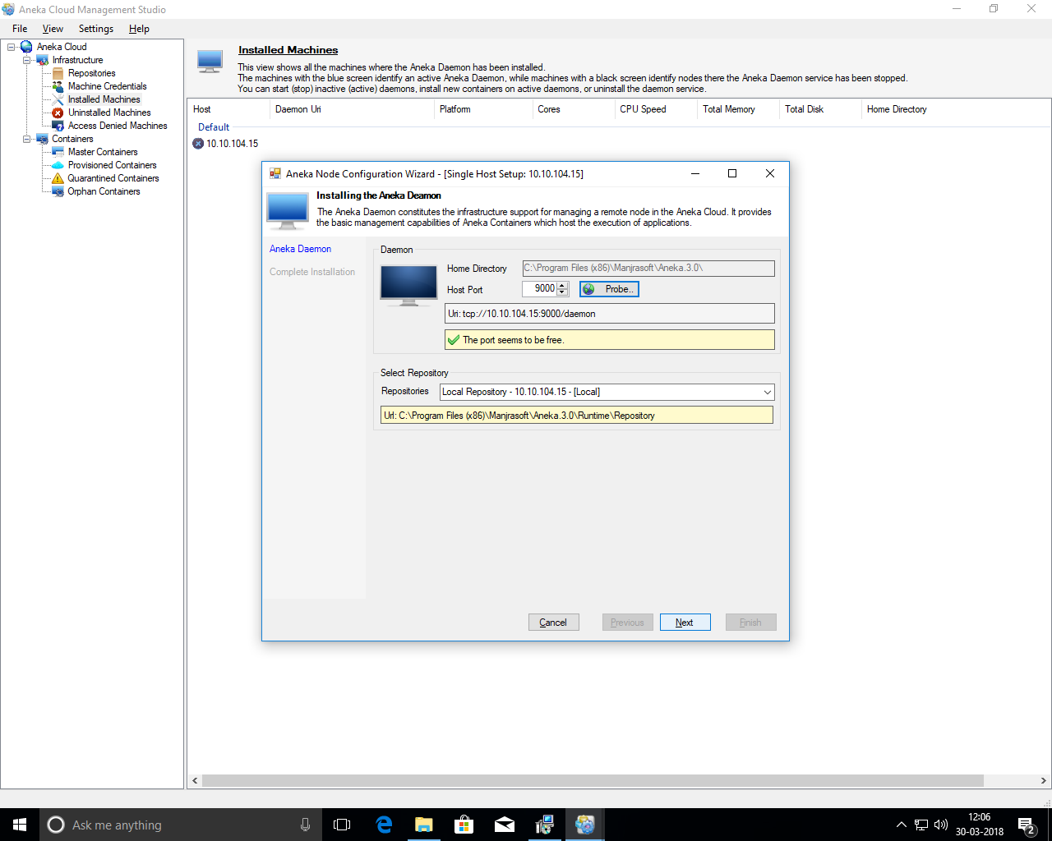

**Step: 33** Click **Finish**

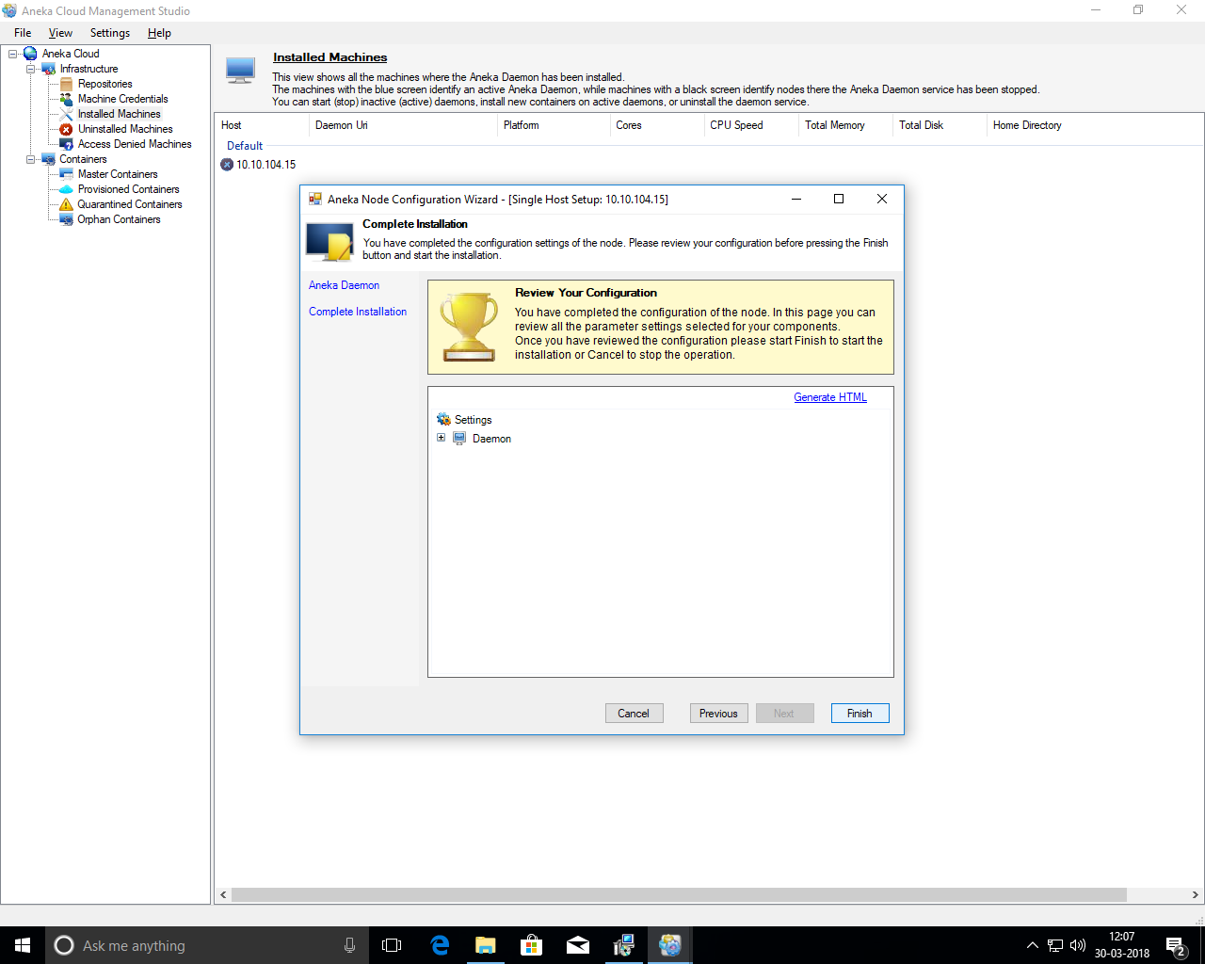

**Step: 34** It will take time to install so, wait for it.

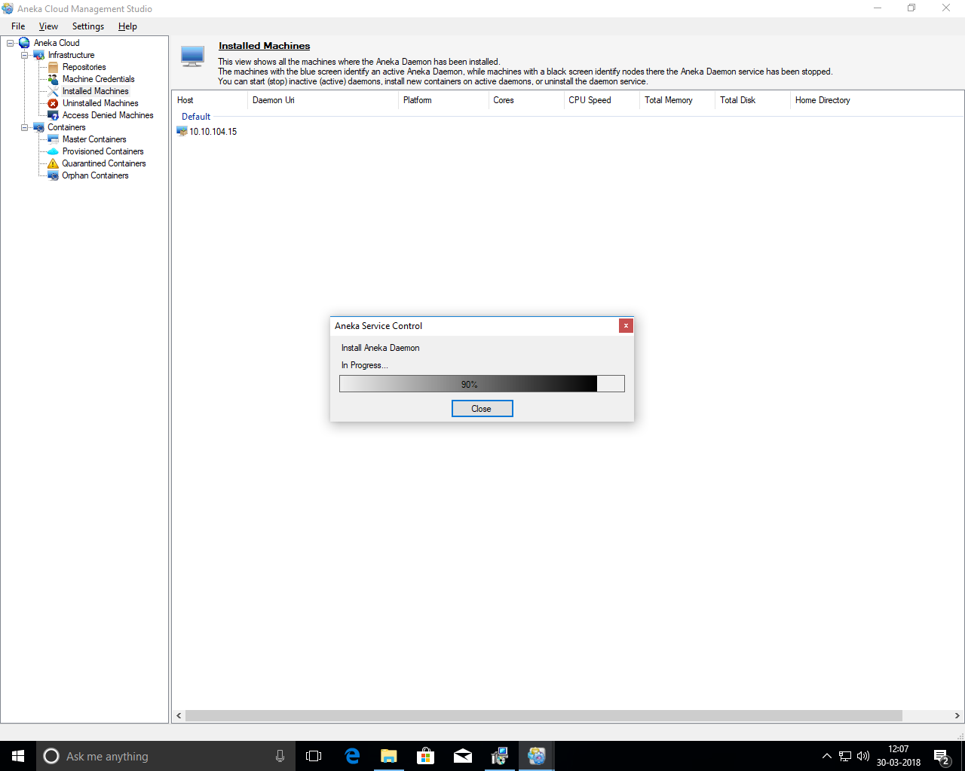

**Step: 35** We can find the installed machine.

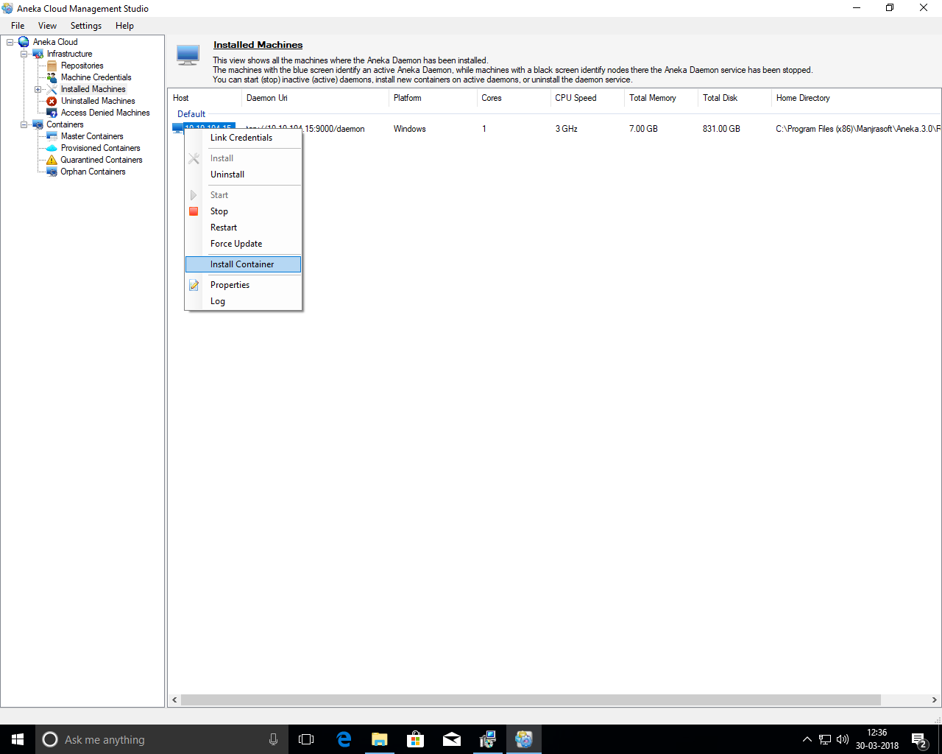

**Step: 36** Right click on it and select install container.



**Step: 37** Write any random port and probe it. We will get its status.

In container type we will select worker.

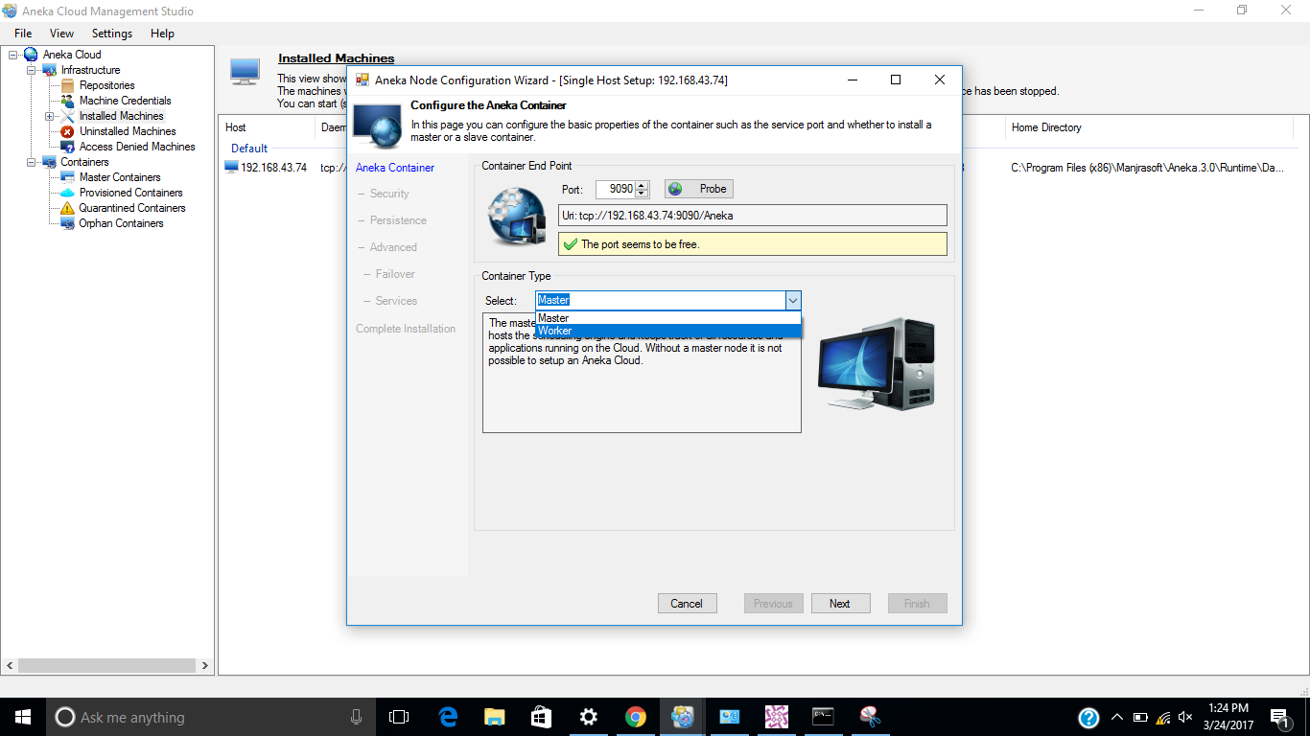

**Step: 38** When we select worker as a container it will require reference Master in which we will provide ip address of master machine and also provide the port of it.

Click probe. It will give the status of reference master.

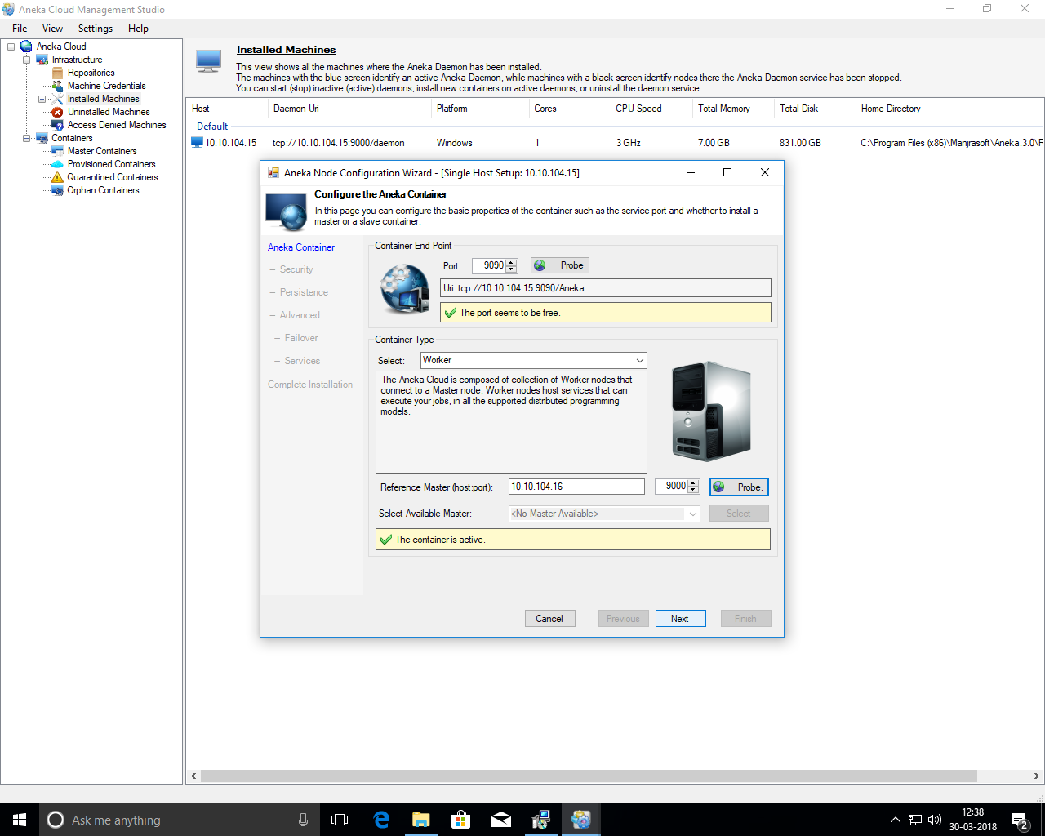

**Step: 39** click **Next**.

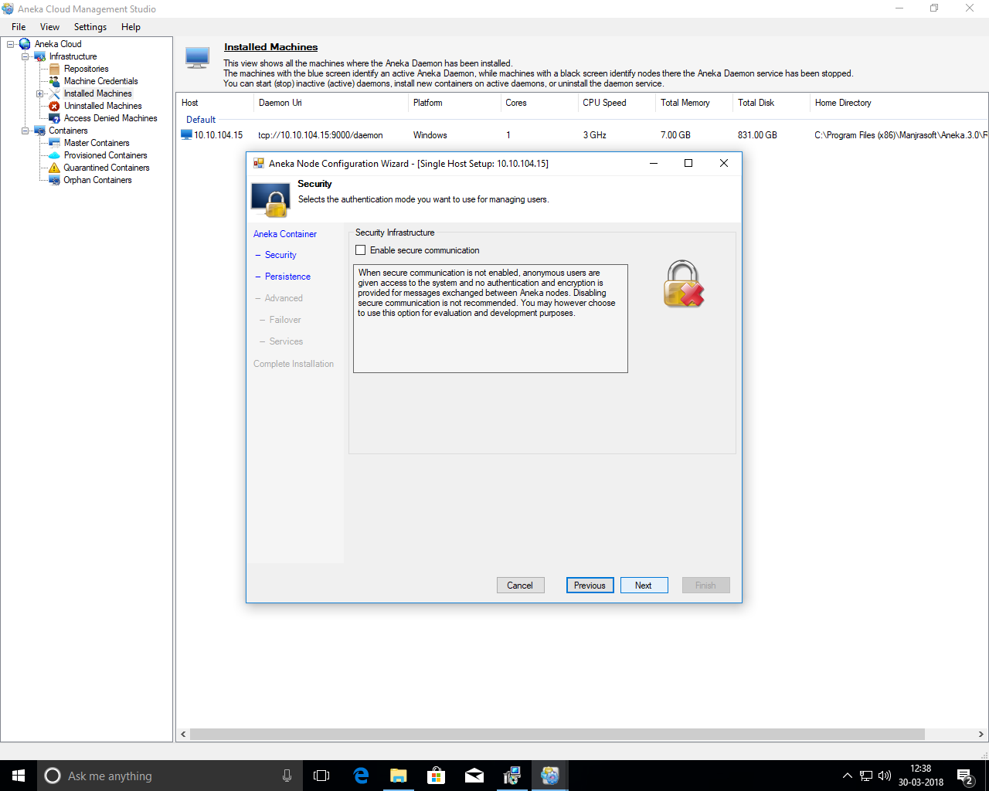

**Step: 40** click **Next**.

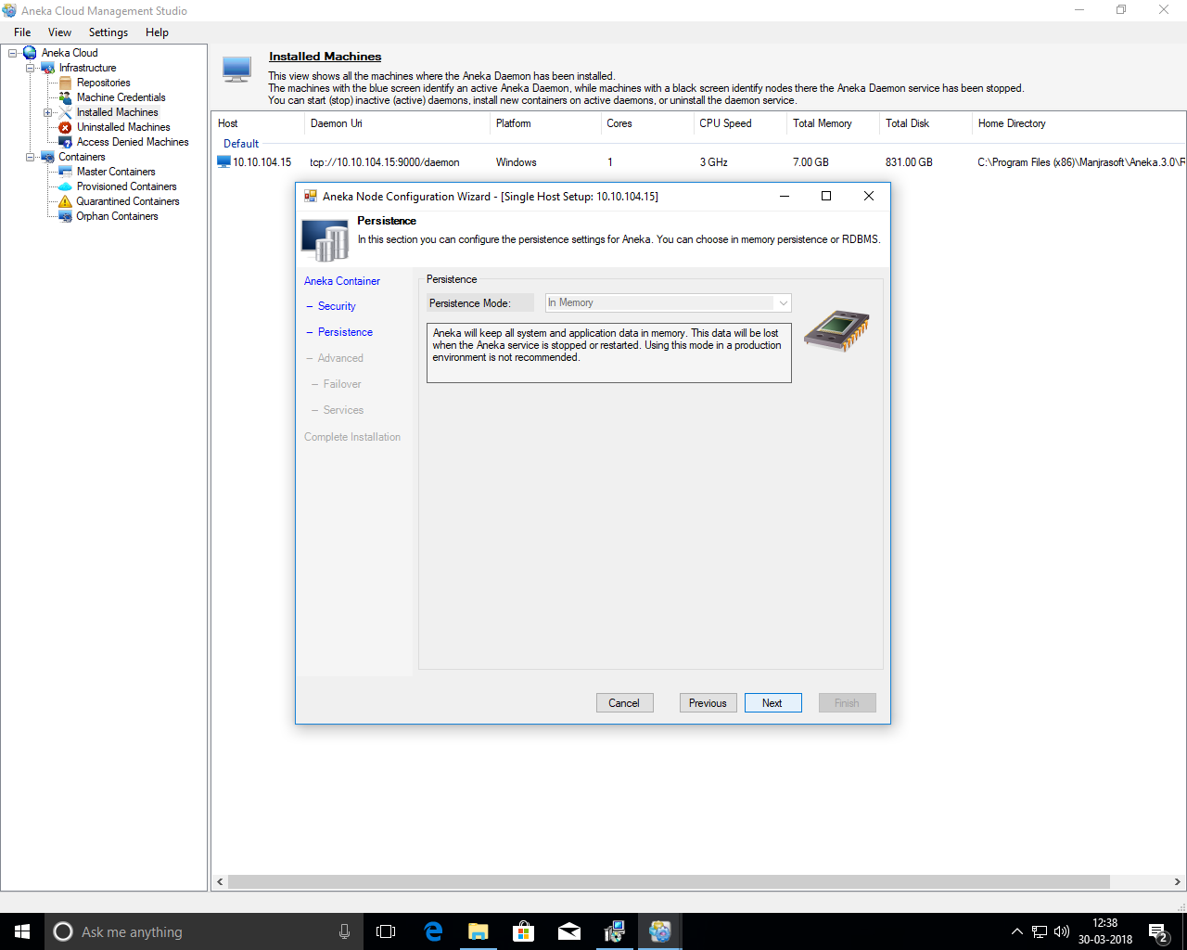

**Step: 41** Click **next**.

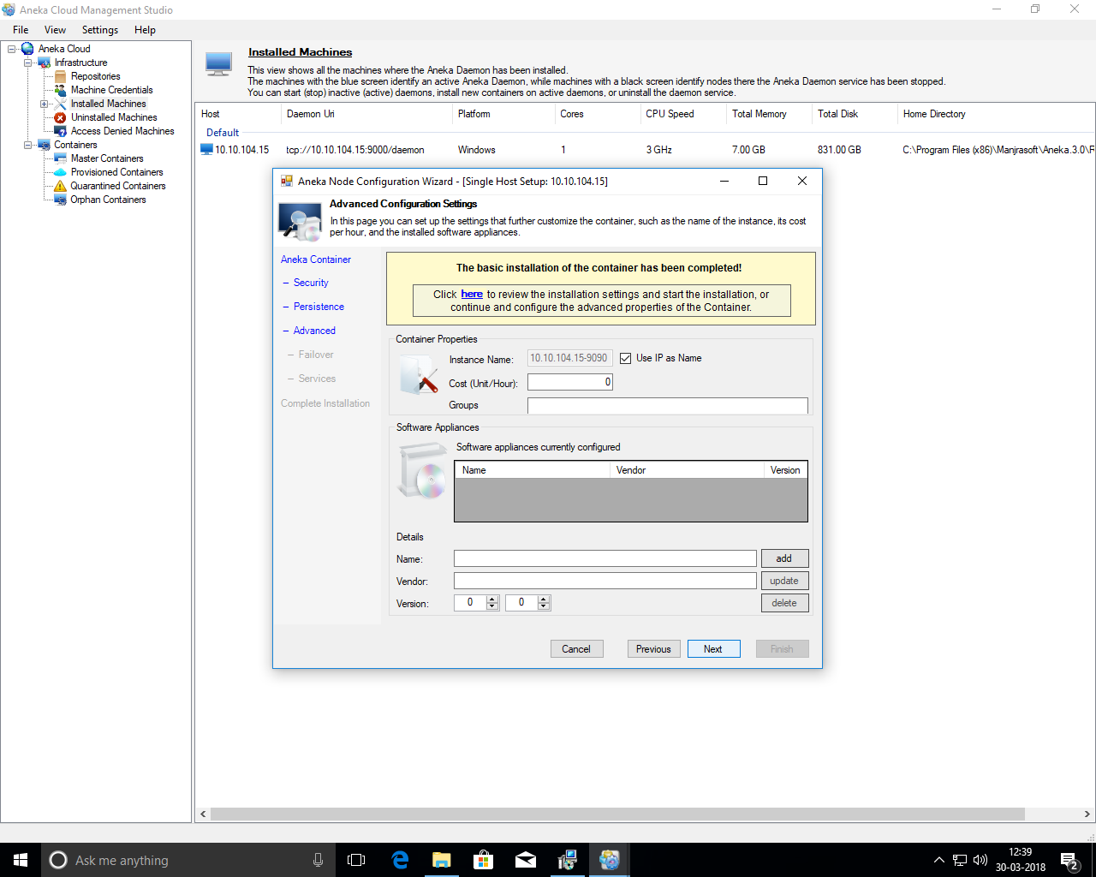

**Step: 42** Click **next**.

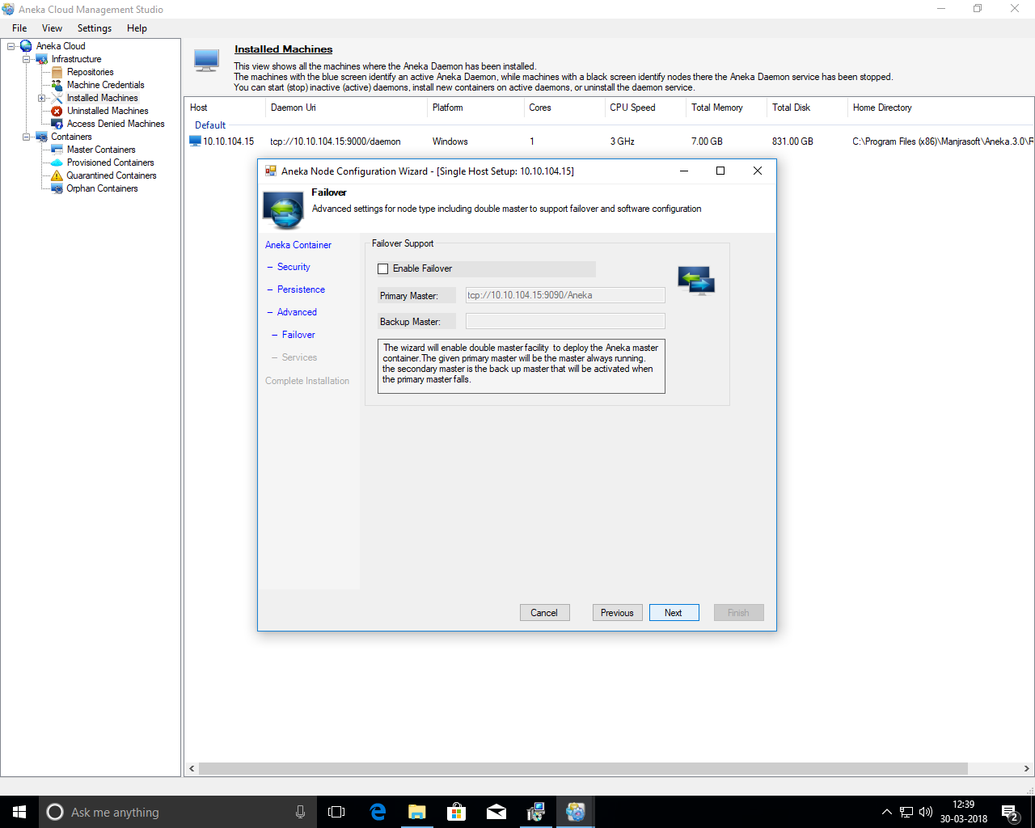

**Step: 43** Click **next**.

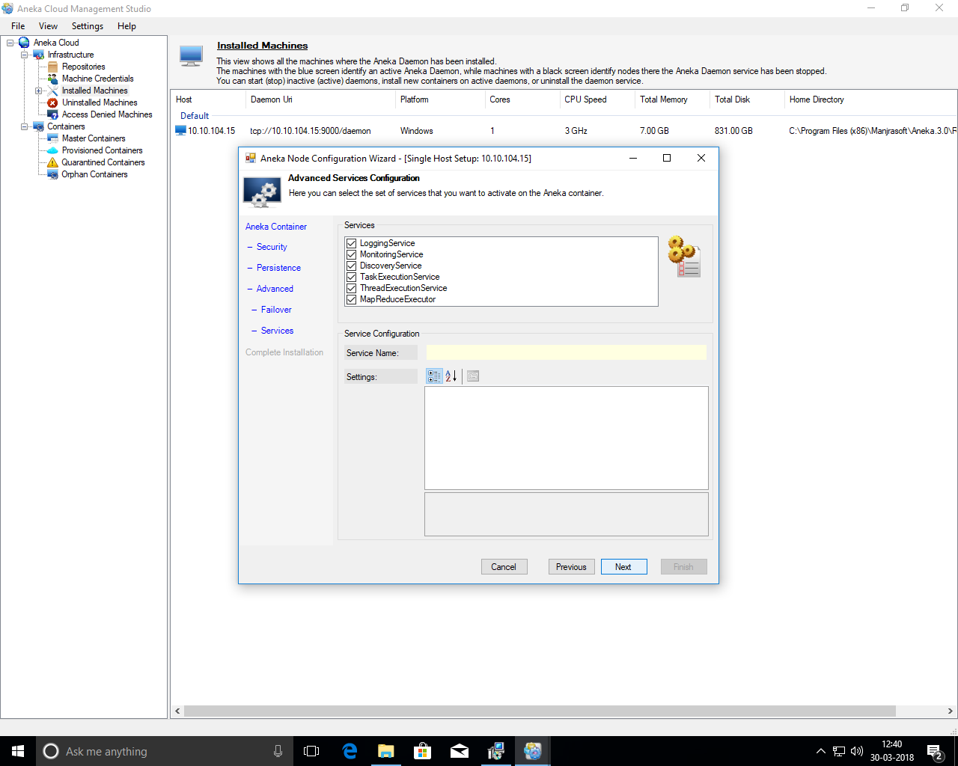

**Step: 44** Click **Finish.**

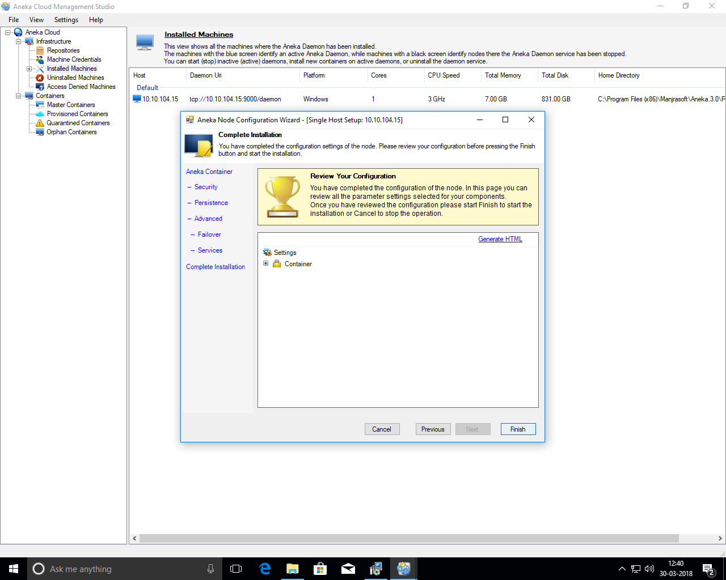

**Step: 45** open Mandlebrot from worker machine.

start > manjrasoft > Mandlebrot.

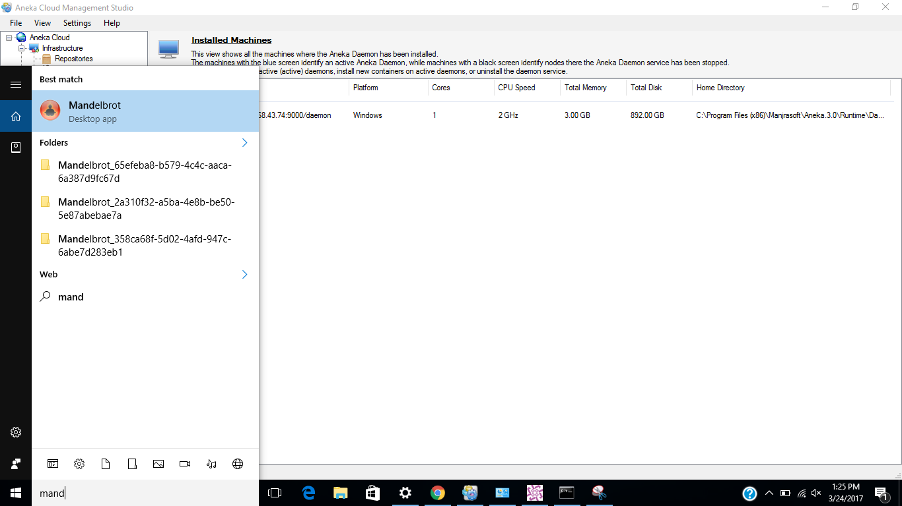

**Step: 46:**Here, we have to add ip-address and port of master and username and password.

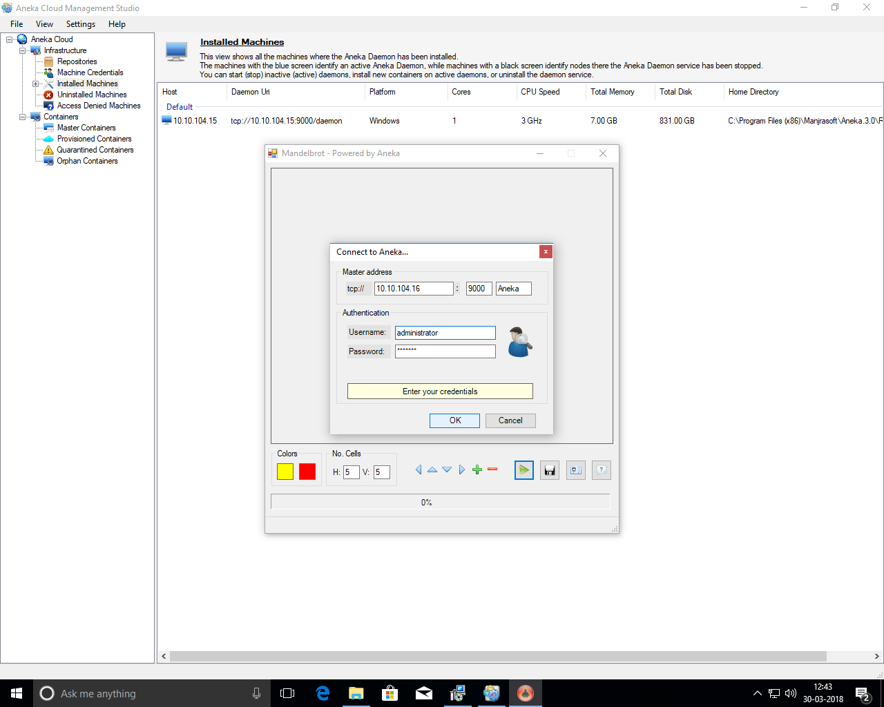

**Step: 46** Click green play button.

When we run first time it require reference of master and also require to enter credentials provided by master. So insert it and click ok.

It will take time to run and once it will finish it’s execution, it will show Application Finished. So, click ok.

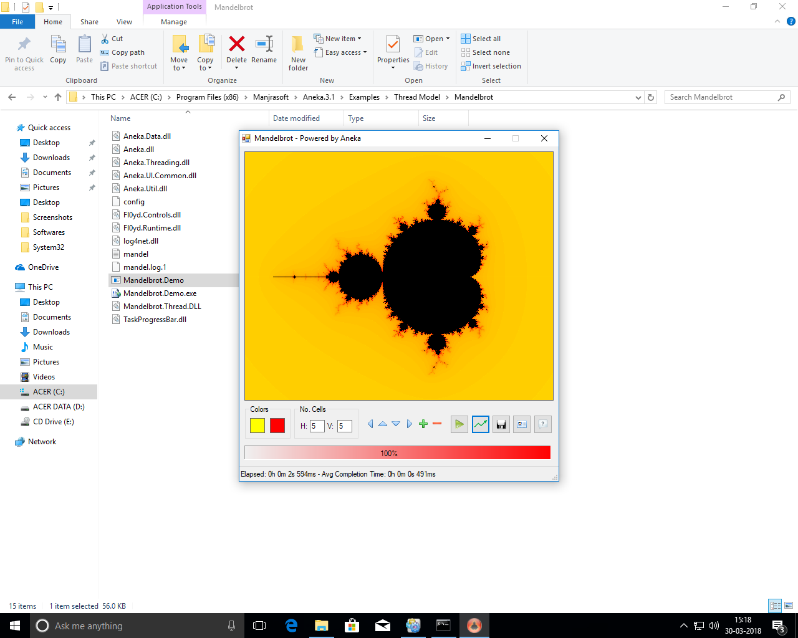

**Step: 47** Now, comeback to the master machine and reporting and accounting.

Aneka management studio > Tools > Reporting and Accounting

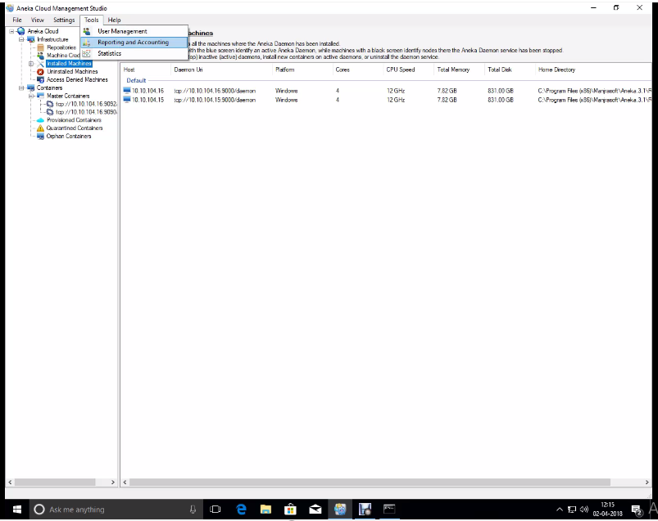

**Step: 48** Select master container and click apply.

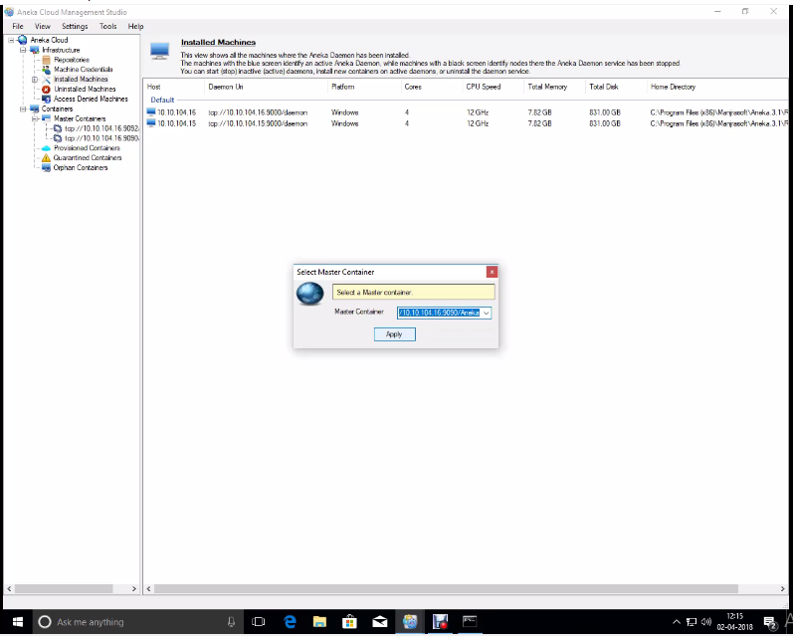

**Step: 49** Click **connect**.

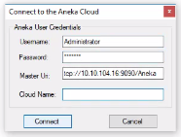

**Step: 50** go to Billing**.**

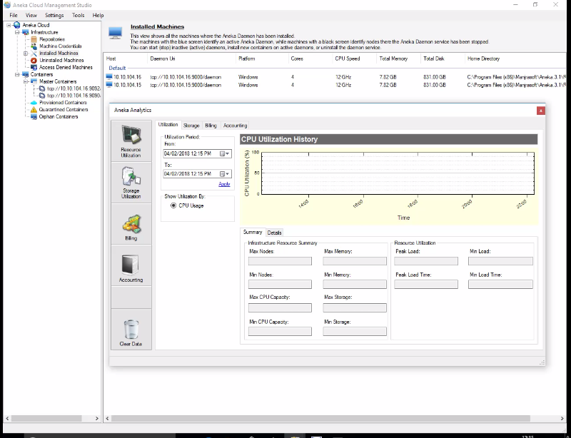

**Step: 51** select billing period and click apply.

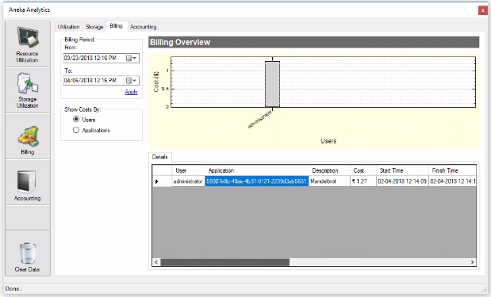

Here, we can see the username, Description (contains name of application), cost, start time, finish time, no. of resources, Total, Completed, Failed, Rejected, etc.

**References**

* **https://**[**www.slideshare.net/shyamkkhadka/aneka-platform**](https://www.slideshare.net/shyamkkhadka/aneka-platform)
* [**http://manjrasoft.com/aneka_architecture.html**](http://manjrasoft.com/aneka_architecture.html)
* **Buyya, Vecchiola, Selvi, *Mastering Cloud Computing***
* **The Structure of the New IT Frontier: Aneka Platform for Elastic Cloud Computing Applications – Part III**